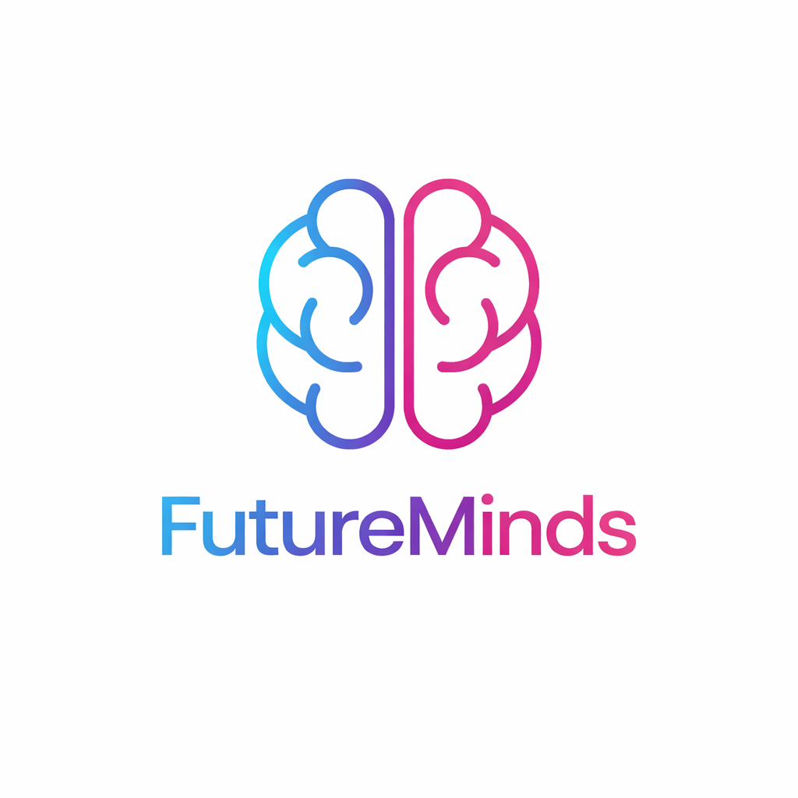
Table of Contents
1. Project Overview 1
1.1 Introduction 1
1.2 Objectives 2
1.3 Key Features 2
2.Technical Specifications 2
2.1 Technology Stack 2
3. Platform Description 3
3.1 User Experience 3
3.2 Course & Lesson System 3
3.3 Assessment and Feedback 3
4. Implementation Details 4
4.1 Core Components 4
4.1.1 User Management Module 4
4.1.2 Course Management Module 4
4.1.3 Assessment & Feedback System 4
5. Development Process 4
5.1 Workflow 4
5.2 Milestones 4
6.Team Structure 5
6.1 Roles & Responsibilities 5
Collaboration Tools 5
7. Conclusion 5
8. References 5

1. Project Overview

1.1 Introduction
The Electronic School is a console-based C++ application that simulates a digital classroom environment. The platform allows students and teachers to interact through virtual courses, manage lessons, submit assignments, and receive feedback. The project aims to combine education with programming concepts, demonstrating structured software design, C++ fundamentals, and algorithmic thinking.

1.2 Objectives
The main objectives of this project are:
- Develop a console-based electronic school platform using C++
- Implement user roles: student, teacher, and administrator
- Provide course creation, lesson management, and enrollment features
- Include assignment submission, assessment, and feedback
- Demonstrate C++ programming skills: arrays, vectors, loops, conditional statements, and functions
- Create a user-friendly console interface

1.3 Key Features
- User authentication and role-based access
- Course and lesson management
- Assignment submission and grading system
- Interactive quizzes and tests
- Real-time feedback for students
- Progress tracking
- Console interface with input validation and error handling

2.Technical Specifications

2.1 Technology Stack
Category | Tools / Technologies
Programming Language | C++
Development Tools | Visual Studio, GitHub
Design Tools | Canva, Photoshop
Documentation Tools | Microsoft Word, PowerPoint
Communication Tools | Microsoft Teams

3. Platform Description

3.1 User Experience
Students interact with a console-based menu system, where they can enroll in courses, view lessons, submit assignments, and see feedback. Teachers can create courses, manage lessons, and grade assignments. Administrators can oversee users and courses.

3.2 Course & Lesson System
Courses are stored in vectors of structures, with each course containing:
- Course name
- List of lessons
- Enrolled students Each lesson can contain text materials and simple quizzes implemented in C++

3.3 Assessment and Feedback
The assessment system provides:
- Quizzes and tests with automated grading using arrays and loops
- Assignment submission tracked with structures and vectors
- Feedback system showing results and improvement suggestions

4. Implementation Details

4.1 Core Components

4.1.1 User Management Module
Manages registration, login, and role-based access.
- Students, teachers, and administrators are stored in vectors of structures
- Input validation ensures secure and accurate data

4.1.2 Course Management Module
- Courses stored in vectors
- Teachers can add lessons and enroll students
- Students can view course content and track progress

4.1.3 Assessment & Feedback System
- Quizzes use arrays for questions and answers
- Automated grading compares student answers with correct solutions
- Feedback displayed in the console after each quiz or assignment

5. Development Process

5.1 Workflow
The team followed a Scrum-based workflow:
- Planning Phase – Requirement analysis, course structure, and user roles
- Implementation Phase – User management, course modules, assessment logic
- Testing Phase – Input validation, grading verification, bug fixes
- Expansion Phase – Feedback system, progress tracking, and console improvements
5. Documentation & Presentation Phase – Preparing final report and slides

5.2 Milestones
Phase | Deliverables
1 | Project scope, course list, team roles
2 | User management and authentication
3 | Course and lesson modules
4 | Assessment system and feedback module
5 | Testing, debugging, final documentation

6.Team Structure

Name | Class | Role
Vanessa Martinova Tsenova | 9B | Developer Backend
Zlati Iliev Georgakiev | 9G | Developer Frontend
Kristiqnana Stoqnova Ivanova | 9B | Developer Backend
Stoqn Dimitrov Tanev | 9B | Scrum Trainer

6.1 Roles & Responsibilities

Collaboration Tools
GitHub – version control
Microsoft Teams – communication
Canva & Photoshop – interface design
Word & PowerPoint – documentation

7. Conclusion
The Electronic School demonstrates a functional C++ console application simulating online learning. It combines programming fundamentals, structured logic, and educational content management, providing an engaging experience for students and teachers. The Null Terminators team successfully implemented all project requirements, combining technical skills with teamwork and planning.

8. References
- C++ Reference Documentation
- Visual Studio Official Guide
- GitHub Documentation
- Educational Software Design Concepts

